Resources handout 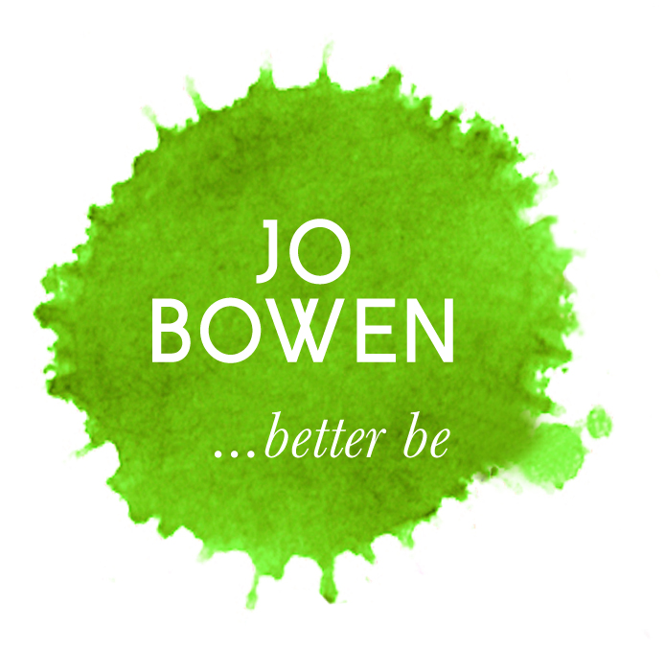
By Jo Bowen, Exeter Stress Clinic

1.7:11 Breathing Exercise
The 7:11 Breathing exercise takes its name from the length of the inhalation and exhalation. The importance of this technique is its emphasis on extending the exhalation which will increase relaxation responses through the autonomic nervous system.
How to do the 7:11 Breathing:
Place your feet firmly on the floor (assertive and grounded position) and hands on your diaphragm which is located underneath the bottom of your ribcage.
Inhale through your nose (mouth closed) for the count of seven.
Pause briefly, then exhale through your mouth (as if blowing out through a straw very slowly) for the count of 11.
Feel your hands moving towards each other as you exhale.
Repeat a few times until you feel more relaxed.
………………………………………………………………………
There are many other breathing techniques (you may have come across square breath, circular breathing, power breath or mouth breath) however I think this one works best at the outset to give you maximum self-soothing. You can use cue cards to help you remember to practice this breathing so as to enhance your relaxation response on an everyday basis.

2.Quick Body Scan
A Quick Body Scan can be done several times throughout the day. Regular body scans get you to notice and release tension in your body and help you to become more attuned to what your body needs. Body scans can help increase overall levels of mental and physical relaxation.
How to practise body awareness throughout the day.
While you are going about your normal activities, try to scan your body as often as possible. Notice how you are feeling. Notice where you are holding tension, and use your breath to release it. Imagine looking at your bodily sensations through a zoom lens and listen to any messages your body has for you.

3. CREATING A SAFE/SECURE PLACE-

Via creative visualisation- close eyes or not.

Relax first using 7-11 breath. Practice accessing this state.

Image (Actual or imaginary place)
Find a place with positive associations, where you feel safe, comfortable, peaceful or calm. (Avoid images containing close family members/pets as they usually have both positive and negative associations). If finding it difficult to imagine a peaceful and safe place, spend more time on developing one, if necessary creating an imaginary one. Identify an image that can easily evoke relaxation and which creates a personal feeling of calm and safety.
Try to notice any sounds, pleasant smells and/ or sensations associated with the image.
Cue word- helps to remind and access the state-what will you call this place of yours?
……..……………………………………………..………………………

